10/10/2025

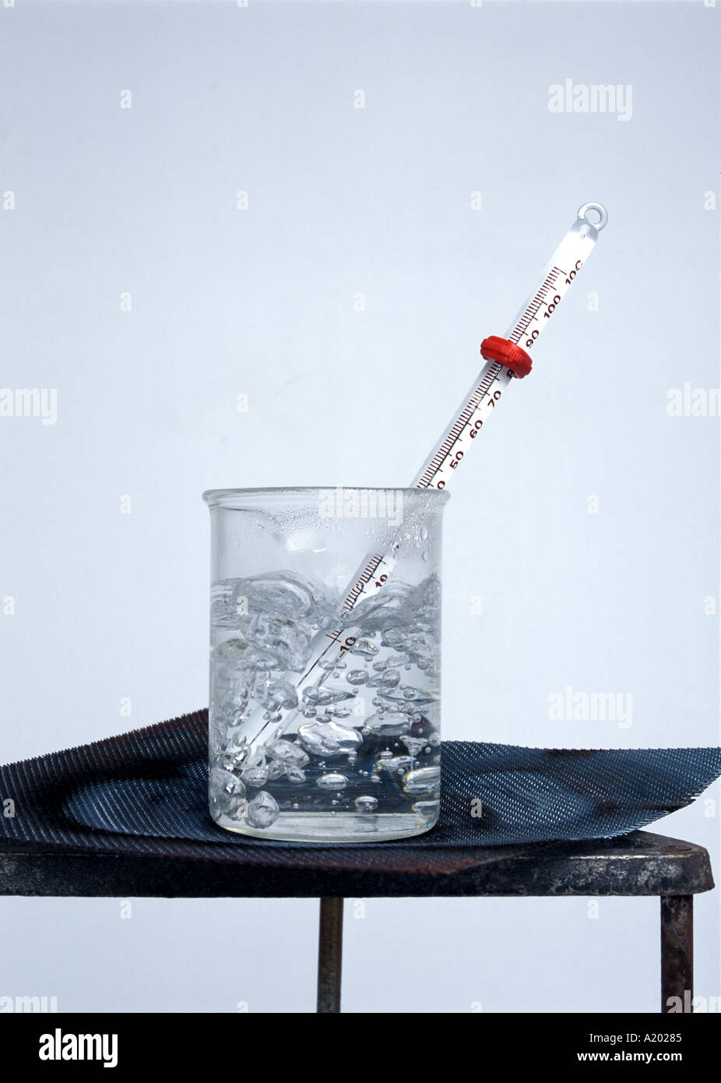

(20117522) Euan Wheatley

Measuring the Boiling Point of Water at Different Altitudes

<https://c8.alamy.com/comp/A20285/glass-laboratory-beaker-on-bunsen-tripod-with-thermometer-showing-A20285.jpg>

Contents

Title ...…………….……………………………………………………………………………………………………………………………… 1

1. Aim 2

2. Theory. 2

2.1 Introduction to Clausius–Clapeyron equation. 2

2.2 Relationship between boiling point and pressure 3

3. Apparatus 3

4. Method 4

5. Calculations 4

6. Discussion/Conclusion 4

## Aim

To determine how altitude affects the boiling point of water and to compare the measured values with theoretical expectations.

## Theory.

### Introduction to Clausius–Clapeyron equation.

The **Clausius–Clapeyron equation** describes how the pressure and temperature of a substance are related during a phase change — for example, when a liquid boils or a solid melt.

It shows that as temperature increases, the vapour pressure of a liquid also increases. This is because heating gives the molecules more energy to escape from the liquid surface.

In this experiment, the equation helps explain **why the boiling point of water decreases at higher altitudes:**

* Air pressure is lower at high altitudes.
* According to the equation, lower pressure means boiling happens at a lower temperature.

### Relationship between boiling point and pressure

The relationship between boiling point and pressure can be estimated using the Clausius–Clapeyron equation:

$$\ln\left(\frac{P_{1}}{P_{2}}\right)=\frac{(ΔH_{vap})}{R}(\frac{1}{T_{2}}-\frac{1}{T_{2}})$$

where $ΔH_{vap}$ is the enthalpy of vaporization, R is the gas constant, and T represents absolute temperature?

## Hot Plate- Principle, Parts, Procedure, Types, Uses, ExamplesApparatus

* Thermometer
* 250ml beaker
* Hot plate
* Distilled water
* Barometer
* Stopwatch

[https://microbenotes.com/wp-content/uploads/2022/11/Parts-of-Laboratory-Hot-Plate.jpg](%20%20%20%20%20%20%20%20%20%20%20%20%20%20%20%20%20%20%20%20%20%20%20%20%20%20%20%20%20%20%20%20%20%20%20%20%20%20%20%20%20%20%20%20%20%20%20%20%20%20%20%20%20%20%20%20%20%20%20%20%20%20%20%20%20%20%20%20%20%20%20%20%20%20https://microbenotes.com/wp-content/uploads/2022/11/Parts-of-Laboratory-Hot-Plate.jpg)

## Method

* Fill a 250 mL beaker halfway with distilled water.
* Measure and record the atmospheric pressure using a barometer.
* Place the beaker on a hot plate and heat gradually.
* Record the temperature at which vigorous boiling begins.
* Repeat the experiment at three simulated altitudes by adjusting the air pressure in a sealed chamber (or use provided data).
* Record all data and calculate the boiling point deviation from the theoretical 100 °C.

|  |  |  |  |
| --- | --- | --- | --- |
| Altitude (m) | Pressure (kPa) | Boiling Point (°C) | Deviation (°C) |
| 0 | 101.3 | 100.0 | 0.0 |
| 500 | 95.5 | 98.6 | -1.4 |
| 1000 | 89.9 | 97.2 | -2.8 |
| 1500 | 84.2 | 96.0 | -4.0 |

## Calculations

Percentage deviation from standard boiling point (100 °C):

$$Percentage deviation=\frac{100-T_{measured}}{100}×100$$

At 1500 m, deviation $=\frac{4}{100}×100=4\%$

## Discussion/Conclusion

* The data clearly shows a decrease in boiling point with increasing altitude, consistent with the theoretical relationship between pressure and temperature.
* Minor experimental deviations could result from thermometer calibration or inconsistent pressure readings.
* This experiment demonstrates the importance of considering environmental conditions in temperature-sensitive scientific measurements.